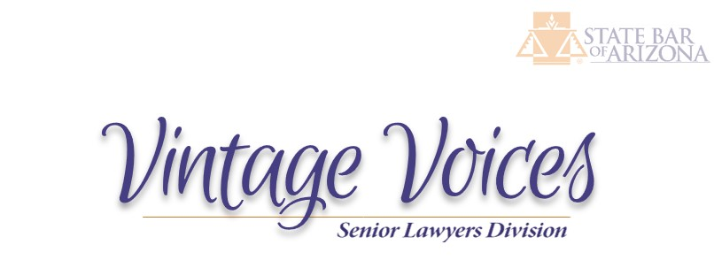
A publication of the Senior Lawyers Division of the State Bar of Arizona

Division News

Catching up on what has happened since March of 2025:

- The Supreme Court approved our proposal to change Rule 32 so our own Division President, Mary Helen Maley Maynard, now serves on the Board of Governors.
- Our Division and the Young Lawyers Division have a formal mentorship program.
- Thanks to Dave Stoller and Mary Helen, the Arizona Supreme Court is working with the Sixth Amendment Project to address pretrial representation for defendants at their initial appearance.
- John Messing has brought us interesting and well-attended Drop-Ins on a variety of topics.
- Chuck Thomson is our Division representative on the Bar Improvement Committee.
- David Vasquez and Walter Nash have made some great friends with Pro Bono organizations statewide.
- Chuck is leading the Access to Justice Working Group to help streamline the certification process for retired and inactive Division members to perform pro bono services. This will involve yet another Supreme Court rule change (Rule 38).

Rule 38 news

Our Access to Justice Working Group discovered that two other entities are reviewing Rule 38. The Supreme Court has a Task Force that is reviewing and restyling all of its rules. We are in contact with the Task Force working group to which Rule 38 is assigned. The Supreme Court also has a formal Commission on Access to Justice. Chuck Thomson recently spoke to that group about Rule 38, they were impressed, and we have plans for collaboration.

Our Division’s main concern is that its retired and inactive members need to go through a rather byzantine process under the current Rule 38 to become certified to provide pro bono services and many have become discouraged. We want to encourage pro bono participation. We will keep you informed of our progress.

Civic Activities

Division members attended the February 12 Rule of Law Day ceremonies statewide. Division members have been participating in mentorship activities with the University of Arizona Law College. Division members serve on the Board of Governors and Bar Improvement Committee. Our Division Executive Council also has Lorraine Arkfeld, the former President of the ABA Senior Lawyers Division, as its ABA liaison.

Educational Activities

Division members have access to excellent and free Drop-In sessions. Our next one will be on March 30 at 12N, which will feature how to use artificial intelligence to increase access to justice. We have a new Working Group, led by Neil Irwin, devoted to Retirement and Future Options. Please consider joining our Creative Writing Listserv to learn more from our own author extraordinaire, Gary Stuart.

Guest Article
By Executive Committee Member, Marshall A. Lehman
From his Lessons Learned From a Lifetime of Lawyering

Over Labor Day in 1970 the Arizona Canal ruptured in the wake of an unprecedented downpour, causing flooding of some 400-500 homes in Scottsdale immediately south of and adjoining the Canal. Preliminary engineering inspections revealed that lack of maintenance of the Canal had resulted in large gopher colonies in the Canal banks as the proximate cause of the Canal break.

A now senior lawyer admitted to practice in 1969 had just completed a federal court clerkship with Hon. Carl A. Muecke, District of Arizona, and was in his first month of the private practice of law as the only associate of Mariscal & Weeks. He drew the assignment of interviewing the homeowners for their version of the events and collecting paid receipts and the like to support their damage claims.

One early evening after a day in the field doing the legwork, he saw Phil Weeks in the firm law library. Asked what he was working on, Phil said, "jury instructions." The young lawyer blurted out, "Jury instructions? That's the last thing we have to do."

The senior lawyer, in his understated way, quietly explained to the incredulous rookie that in litigation you need to know where you're going before you start. He likened the jury instructions to a recipe.

With the recipe in hand, the young lawyer was much better focused and equipped to collect the necessary ingredients: the facts and the evidence to prove them.

The life lesson learned could be labeled “Do the Last Thing First.” Another shorthand descriptor is The Bake a Cake Method of Litigation: First You Need A Recipe.

Editor’s note: Marshall’s case ultimately went to the Arizona Supreme Court in Salt River Valley Water Users’ Association v. Giglio, 549 P.2d 162, 113 Ariz. 190 (1976).

Recommended Reading:

Adaptive Listening: How to Cultivate Trust and Traction at Work, Lowenbraun & Stephens, Duarte: 2024

American Midnight: The Great War, a Violent Peace, and Democracy’s Forgotten Crisis, Adam Hochschild, Mariner Books: 2022

Anthropic CEO Dario Amodei’s essay at https://www.darioamodei.com/essay/the-adolescence-of-technology

Recommended Viewing:

Harry Wild, on Acorn, which is about a retired professor turned detective in Dublin, Ireland. Jane Seymour is fabulous.
Matlock, on CBS, second season, still full of ethics violations. Kathy Bates steals the show.
Still waiting for the next season of The Diplomat on Netflix.
Now, admit it, how many of you watched all of Stranger Things?????

Worth repeating from last year:
Thoughts for These Turbulent Times:
Be kind.
Give the other the benefit of the doubt.
Honor the absent.
Don’t be a jerk.
Listen patiently to someone who is long-winded, boring, or complaining.
Release yourself from that grudge.
Thanks to Fr. Eric Tellez and Fr. James Martin, SJ

Stay cool and see you at the Drop-Ins,

Denise

